19.27: a) For an isothermal process,

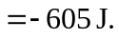

b) For an isothermal process for an ideal gas, 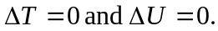 c) For a process with 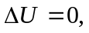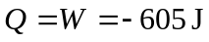; 605 J are liberated.

